Press Release
July 29, 2005
Contact Media Services
202-344-1780
www.cbp.gov

COMPANIES USING WOOD PACKAGING MATERIAL TO IMPORT THEIR GOODS: ENFORCEMENT BEGINS ON SEPTEMBER 16

Washington, D.C. – On September 16, 2005, U.S. Customs and Border Protection (CBP) will begin enforcement of the United States Department of Agriculture’s (USDA) Animal and Plant Health Inspection Service (APHIS) import regulation for wood packaging material (WPM). The rule requires WPM, such as pallets, crates, boxes, and dunnage used to support or brace cargo, to be treated and marked. In cases of noncompliance, the WPM will be subject to immediate export along with the accompanying cargo.
CBP is charged with the important mission of preventing terrorists and terrorist weapons from entering the United States, while also facilitating the flow of legitimate trade and travel. Facilitating trade includes administering the laws and regulations designed to prevent the introduction of pests and agroterrorism that could prove extremely damaging to the U.S. economy.
“The regulations on wood packaging material are necessary to ensure we avoid potentially severe damage to U.S. economic and agricultural interests,” said CBP Director Michael C. Mullen, Office of Trade Relations. “I am asking the trade community to provide its full attention to this issue to ensure your company’s compliance with this rule. Do not risk the exportation of your cargo because of noncompliant wood packaging materials.”
The approved treatments for wood packaging material are 1) heat treatment to a minimum wood core temperature of 56ºC for a minimum of 30 minutes or 2) fumigation with methyl bromide. To certify treatment, the WPM must be marked with the following International Plant Protection Convention (IPPC) logo. Paper certificates of treatment will no longer be required or accepted.
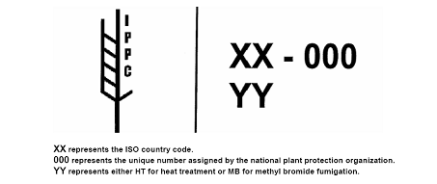
Additional information on the enforcement of the wood packaging material regulations will be available soon at the U.S. Customs and Border Protection’s Web site at www.cbp.gov.
# # #
U.S. Customs and Border Protection (CBP) is the unified border agency within the Department of Homeland Security charged with the management, control, and protection of our Nation's borders at and between the official ports of entry. CBP is charged with keeping terrorists and terrorist weapons out of the country while enforcing hundreds of U.S. laws.

